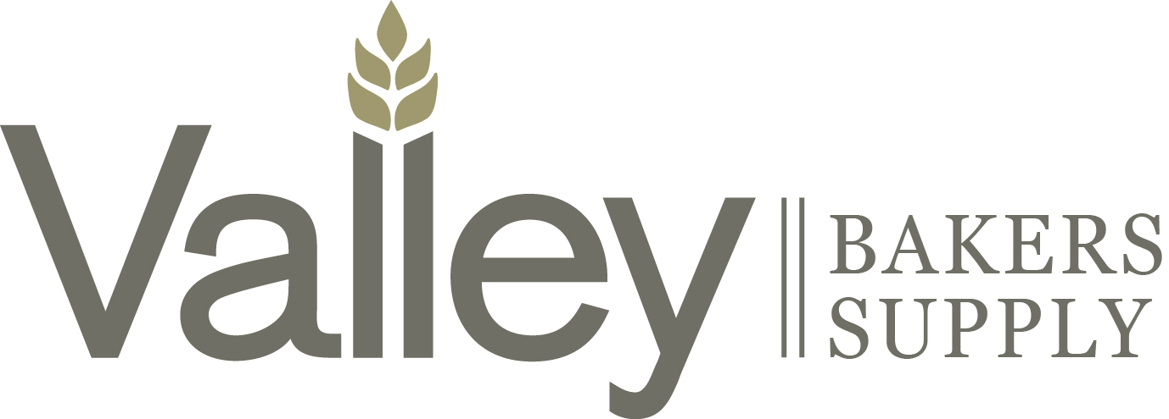

New Vendor Application
Thank you for your interest in becoming a vendor to Valley Bakers Cooperative Association. We currently serve over 1200 customers and members throughout Wisconsin and the UP of Michigan. These customer and members span 7 different target markets from retail bakeries to in-store bakeries and delis to institutional accounts to industrial manufacturers. Valley Bakers continuously strives to provide the highest level of quality products, competitive pricing, and service to our membership and ask the same from our vendors. Please ensure you are prepared to meet the financial obligations necessary to introduce and support your line.

Support Considerations
- Ongoing Marketing Rebate
- Product Samples
- VBCA Food Shows and Events
- Customer Ad Support
- Sales Meetings
- Sales Work-withs

Vendor Information
COMPANY INFORMATION
Company Name
DBA Company Name
Address Line 1
Address Line 2
City
State
Zip Code
PRODUCT INFORMATION
Category of products? | (Dropdown Box?)
Does your packaging have UPC or EAN?
Shipping temperature?
Storage temperature?
Shelf life from date of production?
How do you display code date?
Shelf life guarantee at time of arrival?
Current distribution in WI and UP of MI

REMIT TO INFORMATION
Address line 1
Address line 2
City
State
Zip Code
Telephone number
Fax number

ACCOUNTING INFORMATION
A/R contact name
A/R contact email address
A/R contact telephone number
A/P contact name
A/P contact email address
A/P contact telephone number
Payment terms
Taxpayer identification number
Exemption status – If exempt, please provide W-9

TRANSPORTATION INFORMATION
Physical pickup address
City
State
Zip Code
Contact name
Contact telephone number
Appointment required
Hours of operation
Pallet exchange / Price per pallet

- Your information will be reviewed by our Purchasing Manager and Buyer of your category and will schedule a meeting if your company and products are being considered.
- If approved, you will be asked to sign our standard NonDisclosure Agreement prior to any meeting.

