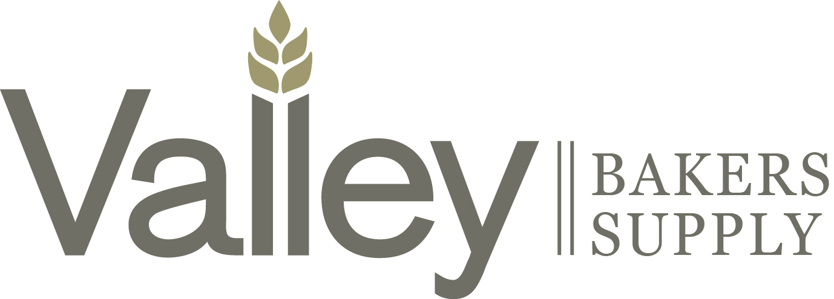

Required Documentation
Prior to Valley Bakers Cooperative Association stocking any new vendors and/or products, please ensure that we have all of the following documentation.
- Nondisclosure agreement.
- Distributor price list.
- New product template.
- Product specification sheet for each new product.
- Product nutritional and ingredient sheet for each new product.
- Kosher certificate(s).
- Most recent 3rd party audit.
- Allergen statement ( if applicable ).
- Certificate of insurance listing Valley Bakers Cooperative Association as certificate holder.
- Country of origin statement.
- Certificates of analysis ( if requested ).
- GMO statement ( if applicable ).
- HACCP program sheet.
- Continuing guarantee and product liability indemnity sheet.
- Lot code interpretation sheet.
- MSDS sheets.

