2nd shift Warehouse Position- Great Pay- No experience required. (Greenville)

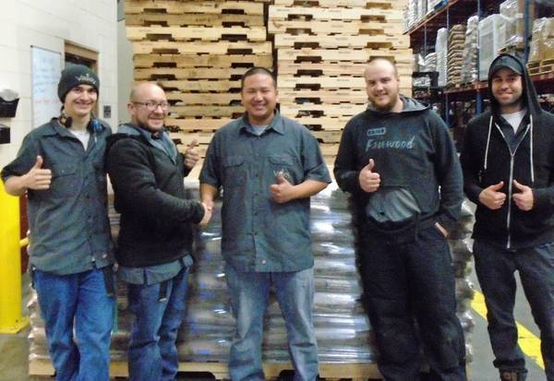

Average annual wage 36K to 48K
full-time Sunday – Thursday (Off Friday and Saturday)
Feeling like you just don’t fit in at your current employer? Find a home at Valley Cooperative!

We are one of the best places to work in the Fox Valley and we were voted 2014 Wholesale Business of the year by the Fox Valley Chamber. We have a dynamic organization where we work hard to achieve results for our members, customers, and our employees.

Candidates who have come to our company in the past have found a better work environment where people treat each other well and respect each other. Valley is a stable company that’s been around for over 68 years and will continue to thrive for a long time, meaning you job security!

This is a role that doesn’t require a lot of technical knowledge, however it does require willingness to work in a cold, (reaching -10 degrees F) physically demanding, warehousing environment. We expect our employees to show up on time, work hard, be respectful to co-workers, and work safely.

Here are some reasons our employees enjoy working at Valley:

- Great wages and incentives.

- Friendly co-workers.

- Floating holidays and other great benefits.

- Fast paced, independent work.

If you’re looking for stable work, a place where your co-workers and management treat you well, where you actually like coming to work, then maybe it’s time to join us at Valley Cooperative!

If you would like to learn more about what makes us a unique and great place to work, please apply at www.valleybakers.com/careers, or stop in and fill out an application. W6470 Quality Dr. Greenville, WI 54942.

