Class A CDL Delivery Driver- Home daily- Great Pay. (Greenville)

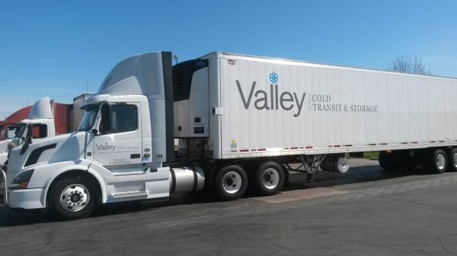

$50,000-$55,000 annually
employment type: full-time
Deliver Driver- All applicants must submit a resume or application for consideration. www.valleybakers.com
GREAT PAY AND BENEFITS!
Valley Cooperative Association in Greenville, WI is looking for energetic, career driven individuals to add to our outstanding team of Delivery Drivers. VCA offers paid on the job training to obtain a class A CDL. Our drivers are praised regionally for their excellent customer service skills, outstanding safety records, and high physical endurance. Valley Cooperative Association is a unique bakery and foodservice wholesale distributor serving Wisconsin and Michigan's Upper Peninsula. Valley offers a full competitive benefits package and encourages employees to lead a healthy lifestyle.
Be willing to work a flexible schedule, which includes working a 4 or 5 day work week. Start time varies and may include 10-14 hours days.
Physical Requirements: Must be physically fit.
Ability to continuously climb, balance, stoop, kneel, and crouch.
Frequent walking, standing, and use of hands and fingers.
Consistently lifting 35-50 pounds and frequently lifting up to 80 pounds from ground and or high elevations.
Pay Scale-
Starting wage $19.73/hour
1 year $21.38/hour
2 year $21.89/hour
3 year $22.43/hour
4 year $22.65/hour
5 & 6 year $23.24/hour
7 year $23.99/hour
Semi annual bonuses paid out at 4.5% based on gross wages.
Here are some reasons why are drivers like working at Valley:
• Wages
• Free Coffee
• Newer Equipment
• Communication between transportation team and drivers
• Office employees are easy to work with and helpful
• Power pallet jacks
• Call in pay
• Having a night manager available at 2am to help with issues

